**UNIT 8: ABILITIES AND REQUESTS**

**Vocabulary**

1. ability /əˈbɪləti/ (n) khả năng
2. request /rɪˈkwest/ (v) (n) yêu cầu
3. sing /sɪŋ/  (v) hát
4. dance /dæns/ (v) khiêu vũ
5. play the guitar /pleɪ ðə ɡɪˈtɑːr/ (v) chơi đàn
6. swim /swɪm/ (v) bơi
7. ski /skiː/ (v) trượt tuyết
8. cook /kʊk/ (v) nấu ăn
9. sew /soʊ/ (v) khâu, may
10. knit /nɪt/ (v) đan
11. draw /drɔː/ (n) vẽ
12. paint /peɪnt/ (n) sơn
13. drive /draɪv/ (v) lái xe
14. fix things /fɪks θɪŋ/ (v) sửa chữa
15. favor /ˈfeɪvər/ (n) sự giúp đỡ, đặc ân

do me a favor = help me : giúp tôi

1. clean the house /kliːn ðə haʊs/ : dọn dẹp nhà cửa
2. cook dinner /kʊk ˈdɪnər/ : nấu bữa tối
3. open the fridge /ˈoʊpən ðə frɪdʒ/ : mở tủ lạnh
4. close the door /kloʊz ðə dɔːr/ : đóng cửa
5. turn on the TV /tɜːrn ɑːn ðə ˌtiː ˈviː / : mở tivi
6. turn off the light /tɜːrn ɔːf ðə laɪt / : tắt đèn
7. hand me my glasses /hænd miː maɪ ˈɡlæs ɪz / : đưa tôi mắt kính
8. **GRAMMAR: CAN AND COULD YOU…..?**

|  |  |  |
| --- | --- | --- |
|  | **Can and can’t + base form** | **Could you +base form** |
| **Usage** | ***To talk about ability.***  Use “***well”*** to indicate degree of ability. | ***Use “Could you”* to make a request.**  Use “***please”*** to make a request more polite |
| 1. **Affirmative statement** | * She can play the guitar. * I can speak English well. |  |
| 1. **Negative statement** | * My brother can’t cook. * I can’t knit well. |  |
| 1. **Question** | * Can you play the guitar?   Yes, I can./No, I can’t.   * Can she draw?   Yes, she can. /No, she can’t. | * Could you wash the dishes? * Could you please wash the dishes? |

1. **GRAMMAR PRACTICE**
2. **Look at the pictures. Write a sentence with can or can’t.**

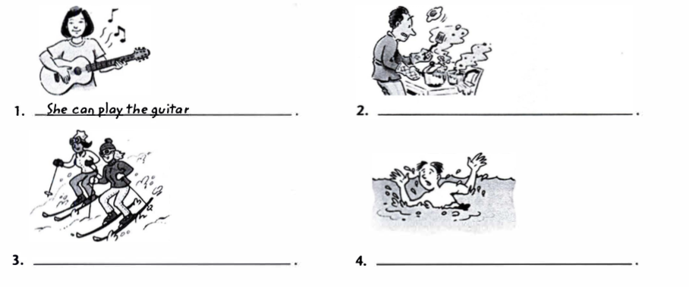

1. **Complete the sentences with can or can’t.**

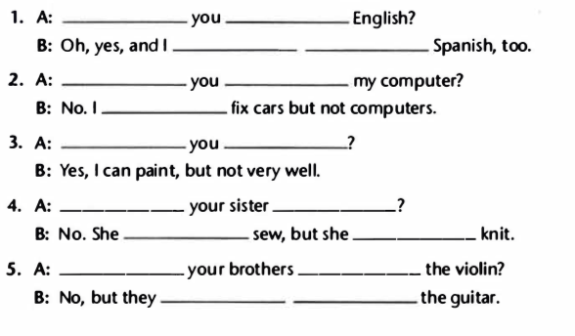

1. **Match the problems with the requests. Write the letter on the line.**

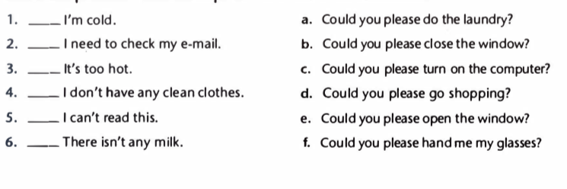

1. **Choose the correct response. Circle the letter.**

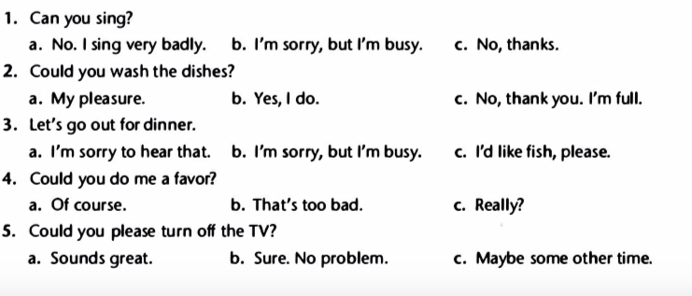

**Further discussion questions for topic 4: Talk about your favorite place**

**1.  What is the exact address of your place?**

Its address is.......................................................

**2.  What is on its right side?**

On its right side, there are......................................................

**3.  What is on its left side?**

On its left side, there are...............................................................

**4.  How do you go to your favorite place?**

I usually take....................................to..............................................

**5.  How long does it take to go there by bus?**

It takes about...................minutes/ hours to go there by bus.

**6.  How long does it take to go there by motorbike?**

It takes about........................minutes/ hours to go there by motorbike.

**7.  How far is it from your house to your favorite place?**

It is about..................meters/ kilometers from my house to.........................

**8.  What can you do there?**

I can................................................................... **(at least 3 things).**

**9.  What is special about that place?**

What makes this place special is.........................................

The most special thing about this place is............................

**10. What is the best way to go there?**

Travelling by.................is the best/ most convenient way to get there.

**Writing task:**

**Hello, teacher**. My full name is..............Today, I would like to talk about my favorite place. It is.................. I usually go to............with my..................in/on..................**(in the free time, on Sundays, on weekends...)**. It is in/at/on................... **(location?)**. It is about ..................meters/ kilometers from my house to.................... I usually take **(my bike, motorbike, bus...)** ..............to get there. It takes about...................minutes/ hours to get there. On the right side of the.........., you can see............. On the left side of the..........., you can see......... **(In this place, you can see.....................)**. I love this place because I can......................... **(list some activities you do).** In my opinion, what makes this place special is.................................. This is a (wonderful/ great/ amazing...) place for me to relax after the hard-working days. That’s the end of my speech. **Thanks for your listening. I hope you like my speech.**